Escola Saber Viver
Data ____ /____ /____
Aluno (a)______________________________________________________________

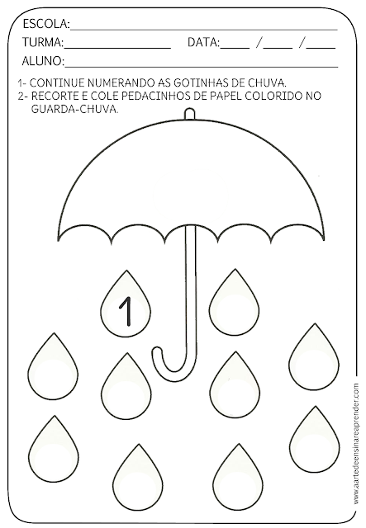
- Continue numerando as gotinhas de chuva com o numeral 1.

Escola Saber Viver
Data ____ /____ /____
Aluno (a)______________________________________________________________
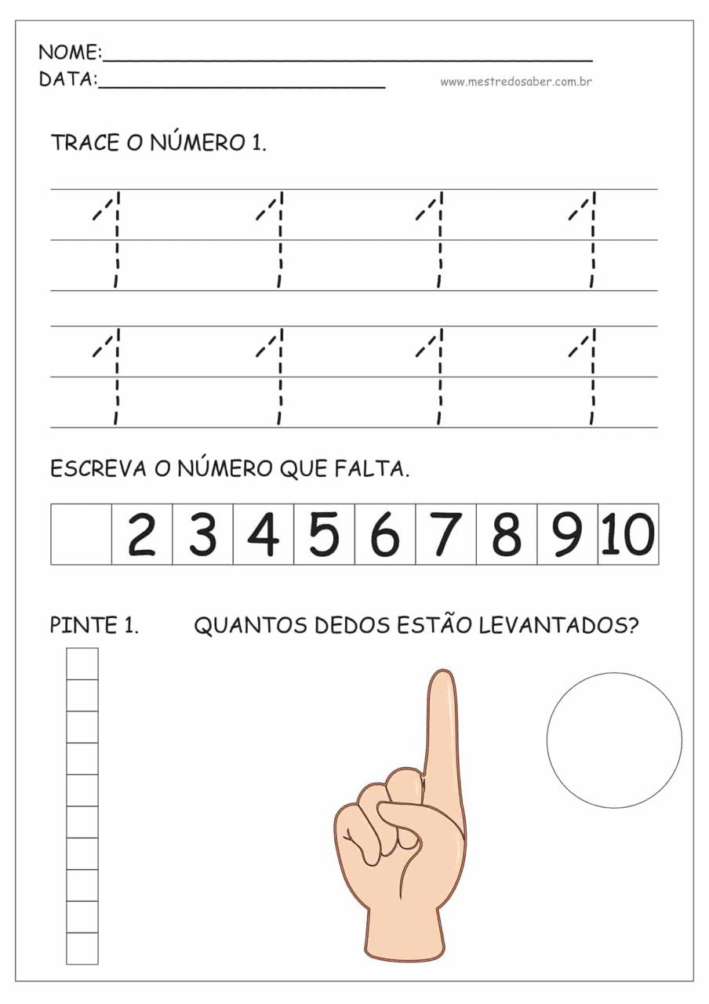

Escola Saber Viver
Data ____ /____ /____
Aluno (a)______________________________________________________________

Escola Saber Viver
Data ____ /____ /____
Aluno (a)______________________________________________________________

- Trace o numeral 0.
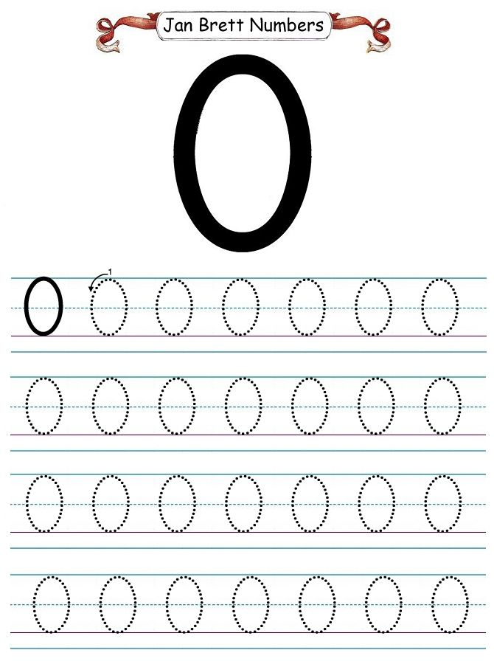

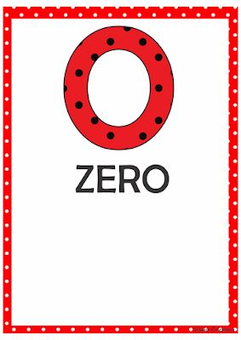

Escola Saber Viver
Data ____ /____ /____
Aluno (a)______________________________________________________________

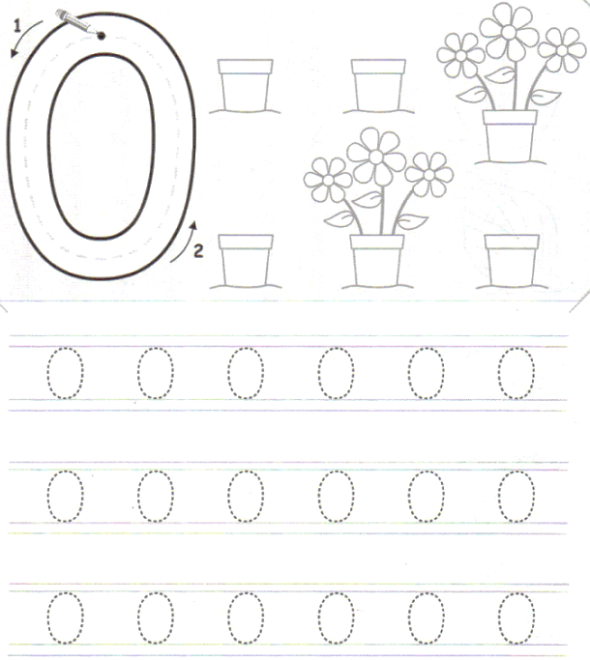
- Pinte o numeral 0 e os depois trace os pontilhados.

