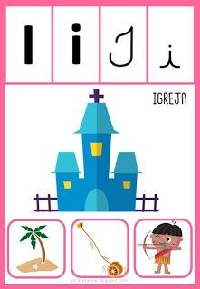
Escola Saber Viver
Data: ____ /____ /____
Aluno (a)___________________________________________

